TEL-RP2111

COMPUTERIZED CAVENDISH
BALANCE

TEL-Atomic, Incorporated
P.O. Box 924
Jackson, MI 49204
1-800-622-2866 – FAX 1-517-783-3213
email: telatomic@mindspring.com
website: www.telatomic.com
COMPUTERIZED CAVENDISH BALANCE

The Computerized Cavendish Balance is designed to allow data to be taken with a microcomputer, analog meter or (for the masochistic) an optical lever arrangement. The period of the unit depends on the length of the tungsten wire and will vary from approximately 3½ to 4½ minutes. The electronics used to collect data are on the PCBV located inside the unit. They are designed such that the pendulous mode (at least to a first order approximation) can be ignored. Thus the TEL-RP2111 Computerized Cavendish Balance is fairly immune to environmental vibrations. (This does not mean however, that you can bump the table when taking data or be reckless when moving the perturbing masses!)

The experiment can be completed in one (long) laboratory period. (This does not include replacing the tungsten wire if that is necessary). Most of this time will be spent setting up and calibrating the unit. Setting up includes forcing the swinging masses to swing near the center line of the Cavendish apparatus. Dampening the swing is required. By letting the boom bounce about the calibration pin, the time to dampen the swing will be much reduced. If the tungsten wire needs to be replaced, we recommend that this tedious task be performed before the laboratory begins. See Appendix A for attaching the wire to the boom.

The actual taking of data can be accomplished in a fairly short time.

SET UP AND CALIBRATION

See figure 1.
With the small lead balls (A) in place on the suspended boom (K) assure that the boom is, as nearly as possible, horizontal and centered between the fixed plates (C This can be accomplished by sliding the small vertical support rod (D1) until the boom is level. Raise or lower the boom with the top support rod (E) to center it between the fixed plates. Also assure that neither the wire support rod nor the boom comes into contact with any part of the unit. If this happens, it is impossible to cause the boom to rotate since the gravitational attraction between the small (≈15gm) and large (≈1kg, not shown) lead balls is a much smaller force than the friction caused by any part of the boom being in contact with any part of the unit.

Insert the glass and place the large lead balls on the large boom. Position the large boom (G) so that the large balls are perpendicular to the face of the unit.

NOTE: When placing or removing the large lead balls, it is good practice to be sure that both balls are placed on or removed from the boom at the same time. If you don't, the unit could tip over and the wire will probably break resulting in very unhappy campers.

Zero Adjust Knob
There is a single knob on top of the small box, which connects to the 6 conductor wire from the Cavendish Unit. This box has few electronics inside and serves simply as a way to connect power to the Cavendish Unit and get the signal from inside the Cavendish Unit to the outside world. The ten turn pot simply serves as an offset to make the signal read at a convenient level. The Cavendish has an output of ≈-5 to +5 volts as the boom swings from “glass to glass”. The 10-turn pot provides an approximate 2.5V offset. In a perfect world, if the boom could be stopped at exactly the center of the sensor inside the Cavendish Unit, one would obtain a zero reading. Due to the very small diameter wire the likelihood of the boom coming to rest in the center is exceedingly small. Therefore, the fine adjust pot simply “offsets” the signal so that when the boom is moving in the “operating area”, the output signal can be offset so that one sees a signal of ≈600-1000mV.

Figure 1. Computerized Cavendish Balance

E

I

J
A
B
C
D2

D1

H

A) LEAD BALLS G) LARGE BOOM
B) SUSPENDED BOOM H) CALIBRATION PIN
C) FIXED PLATES I) KNURLED KNOB
D1) VERTICAL SUPPORT J) 25μ TUNGSTEN WIRE
ROD
D2) SCREW FOR SUPPORT ROD
E) TOP ROD

G

CALIBRATION

Now is a good time to calibrate the unit. Connect a voltmeter or computer interface to the connector box (which is connected to the Cavendish balance) to monitor the movement of the boom. You will need to obtain a voltage reading as each side of the slot in the end of the boom comes in contact with the calibration pin (H). See figure 3.

An easy way to determine the calibration constant is to do so dynamically. With the Computerized Cavendish Unit connected to a Kis or other computer interface. Set the sample rate to at least 10/20 samples/sec. You should get a voltage swing of ≈ 650 mV for the small gap and ≈ 1000 mV for the large gap as the boom swings about the calibration pin. Take data long enough so that you obtain at least 5 - 10 complete boom cycles. Do this for both the large and small gaps.

One can be sure the boom is hitting the slot if the graph has sharp turning points as shown below in
figure 2.
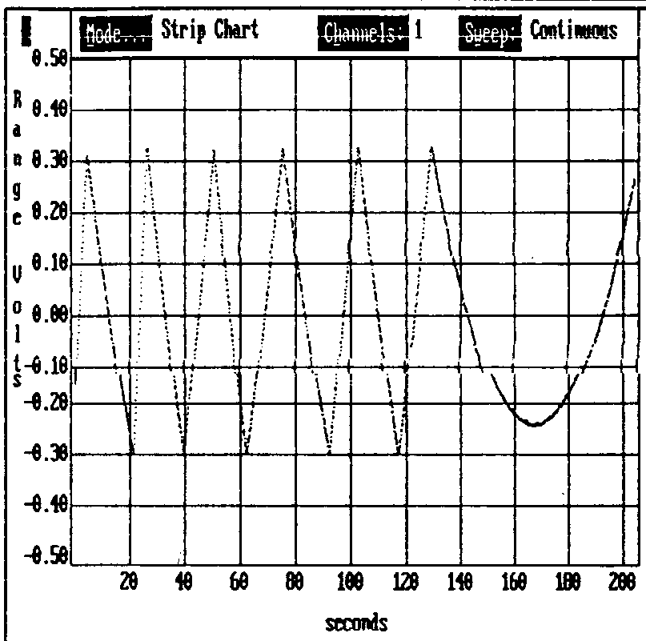
figure 2. Large gap of boom swinging about the calibration pin.

If the boom does not hit the pin, the curve will be sinusoidal without the sharp turning points. Since the boom is balanced, one can assume that the support is (mostly) centered, although there will be small differences in the turning radius of each gap.

The total angle through which the boom rotates is very small (1 - 2°) therefore the tangent of the angle through which the boom swings is approximately that angle in radians. The distance the boom can move is the gap spacing less the calibration pin diameter. Figure 3A.

Figure 3. Suspended Boom (B)

5.875 calibration pin

5.241 .1250

.1560

.062

.080 .080
dimensions are in inches.
all measurements are ± .0005

figure 3A

Gap Spacing

.0625

θ

2.9375

_______________________________________________________________

As you can see in figure 3A, the boom can move a distance of .125 - .062 for the small gap or .156 - .062 for the large gap.

If the support is in the center then tan θ = θ
and for the small gap 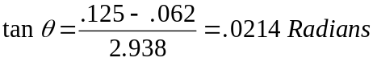.
For the large gap 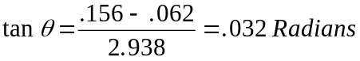.

The fact that the boom support may not be exactly centered is minimized by determining a calibration constant for each side and averaging the values obtained.

One needs to obtain the calibration constant dynamically as described above, rather than by letting the boom come to rest against the pin. This could cause the point about which the boom is turning to move so that the calibration constant obtained would be in error.

(This calibration is a gross method and not recommended for accurate G measurements. A more accurate calibration method is described at the end of this section.)

After calibration, remove the pin. The boom will start to swing. Rotate the top knurled knob (I) to cause the boom to swing near the geometric center of the unit. This is very important. The unit is designed to work near the null position. If the boom tends to stop off center, then rotate the wire so that the boom will move towards the other side.

It is possible (but not likely) that the tungsten wire is completely twisted, perhaps more than one turn, therefore you may have to turn the knob more than 360° to get the boom to swing in the appropriate range. A voltmeter or computer interface connected to the Symmetric Differential Capacitive Control Unit will help determine when the boom is centered.

After the motion of the boom has been appropriately damped, you are ready to begin taking data.

Swing the large perturbing masses so that they just touch the outside glass. Observe the output from the connector box so that when the boom reaches the limit of its rotation, you can swing the large masses so that they will again attract the small mass. Be sure to swing the large masses at the turning points in order to build up the amplitude of the rotation.

You will need to determine the amplitude of the boom on at least three successive swings (more is better) i.e.: θ1, θ2, θ3. (See appendix B for the calculation of G)

After gathering data place the perturbing masses in the neutral position perpendicular to the face of the cavendish balance. Let the small boom rotate in free decay in order to determine βτ . You will need the amplitude of at least three successive swings of the small boom (more is better).

BEST (MOST ACCURATE) CALIBRATION METHOD

A more accurate way to determine the calibration constant is to use an optical lever arrangement.

Place a laser at a distance L from the mirror. Place a meter stick so that the reflected laser beam moves back and forth along this meter stick.

Set up the Cavendish balance so that the small boom is moving through a small angle. The angle should not be significantly greater than the angle through which the small boom will move during the experiment, (1 - 2°).

Measure the distance S (figure 4, not to scale) that the reflected laser beam spot travels while noting the voltage reading (obtained from the output of the connector box) at the successive turning points A & B. The calibration constant is then ΔV/angle in radians.

Mirror on vertical support

figure 4

θ

2 θ

L

Meter Stick

Laser

A S B

S - distance laser spot moves between turning points
L - distance of meter stick to mirror
θ - angle through which small boom moves
2 θ - angle through which the reflected beam moves, (angle is 2 θ because of angle doubling due to reflection)

EXPERIMENT
RESONANCE
You now have all of the data necessary to calculate G. (See appendix B)

APPENDIX A

The tungsten wire is only 25 microns in diameter and fairly fragile, therefore extreme care needs to be taken when tying this wire to the support rods. Carefully unroll and cut off 1 1/2 - 2 feet of wire. Although you only need a few inches it is easier to work with a larger piece of wire. Work in a well lighted area. Thread one end of the wire through the "eye" of one of the support rods. Carefully pull it through. Take two or three turns through the "eye". Be sure the wire is against the surface of the rod. You do not want a "loop" at this point because you want the wire to twist about its axis. Now make a "reverse loop around the cross pieces. There will be enough friction to prevent the wire from slipping. (See figure below)

It is imperative that you do not have any kinks in the wire.

We have empirically determined that those of us who are "old" and who have less than desirable eye/hand coordination are best served if we beg, grovel, plead or do whatever it takes to have a young highly eye/hand coordinated person perform this task. It can be done by such a person in 10-15 minutes. Otherwise be prepared for a patience testing and potentially frustrating experience!
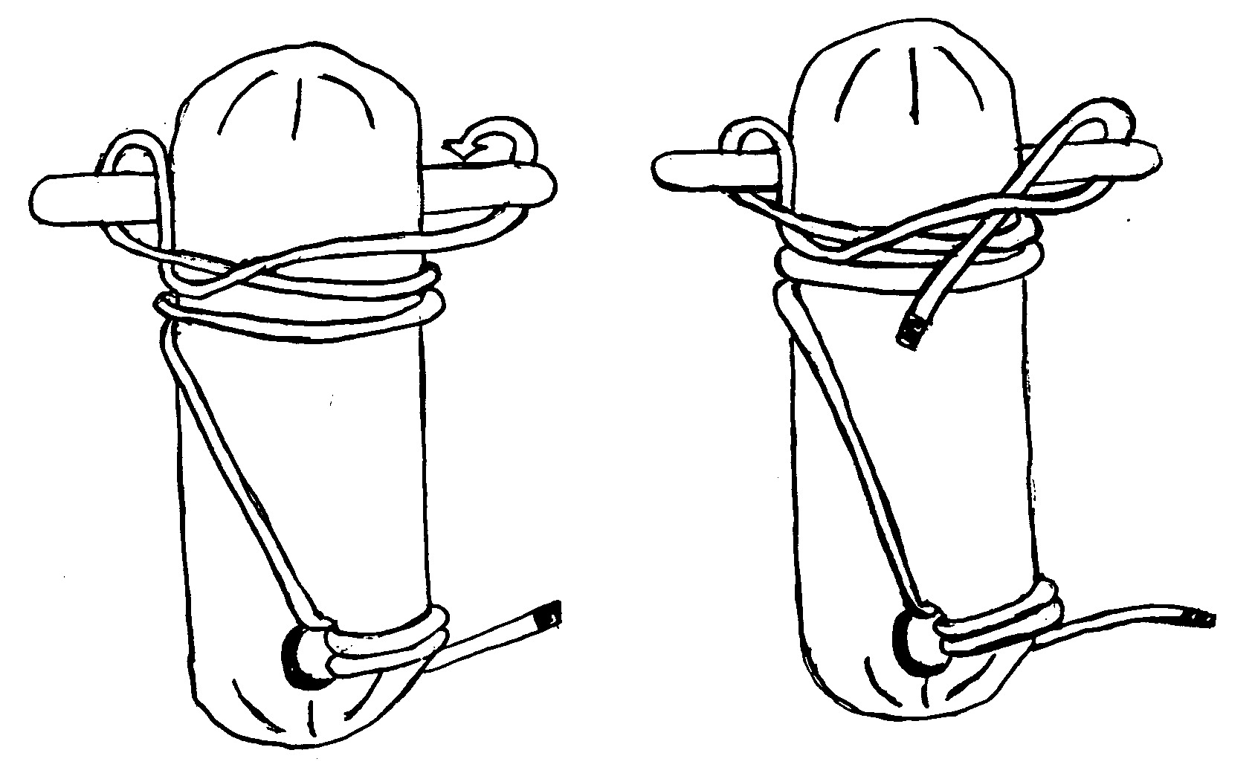

APPENDIX B Calculation of G

The driven resonance method of determining G has the advantage that the experimental data can be collected in a short time since one does not have to wait for the oscillations of the balance to damp away. Measurements can begin at any time the balance reaches a turning point. The large balls are rotated back and forth between the two extreme positions so that the force of gravity between the large balls and the boom is always doing positive work on the balance, and the amplitude builds up until the energy loss from damping is equal to the work done by the gravitational force. Thus, determining G requires knowledge of the damping coefficient of the balance. This is most easily determined by measuring the amplitude decay as the balance is freely oscillating.

When freely oscillating, the angle of the boom as a function of time is given by

θ(t) = θe + A e-bt cos(ω1t +δ) (1)

where

θe = equilibrium angle of the balance,
A = oscillation amplitude at t = 0,
b-1 = time for the amplitude to decay to 1/e of the initial value,
ω1 = oscillation frequency; ω12 = ωo2-b2, ω1 = 2π/T;
ωo = oscillation frequency in the absence of damping; ωo2 = K/I,
T = oscillation period
K = torsion constant of the suspension fiber,
I = moment of inertia of the boom,
δ = phase of the oscillation at the time t = 0,

and where we have made the standard assumption that the damping torque is directly proportional to the angular velocity of the boom. Figure B1 shows for a 50 minute time interval the measured voltage output of the balance in free oscillation along with a least-squares fit to the function given in Equation 1.

Since the large masses are rotated at turning points of the oscillation, it is convenient to define the zero of time to occur at a turning point. In this case, the phase δ is specified by the requirement dθ/dt=0 at t=0, and Equation 1 can be rewritten as

θ(t) = θe + A e-bt [cos(ω1t )+b/ω1 sin(ω1t)]. (2)

In what follows, we will concentrate on the turning points of the motion.

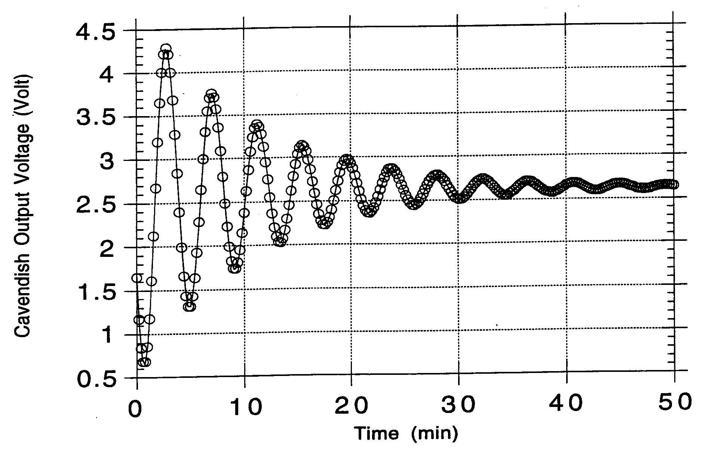
Figure B1. Measured output voltage for free oscillation
of the Cavendish balance.

Let tn be the time of the nth turning point (tn=(n-1)T/2, the first turning point occurs at t=0), and let θn be the boom angle at the nth turning point, θn = θ(tn). The initial amplitude A is then just θ1-θe. From Equation 2 we find

θn = θe + (θ1-θe)(e-(n-1)bT/2) (-1)n-1 (3)

since ω1tn = (n-1)π. The factor e-bT/2 occurs so often in the formulas below that it is convenient to define a separate symbol for it; let’s call it x (x≡e-bT/2). With this definition, Equation 3 becomes

θn - θe = (-x)n-1 (θ1 - θe) (4)

which can also be written in the form:

(θn+1 - θe) = -x (θn - θe) (5)

In free decay, x can be measured using any two adjacent turning points:

x = -(θn+1 - θe)/(θn - θe). (6)

One drawback to using Equation 6 to measure x is that it requires knowledge of the equilibrium angle, θe. By using three adjacent turning points, only differences in the turning point angles need be measured. Using Equation 5 twice, we find

x = -(θn+2 - θn+1)/(θn+1 - θn). (7)

Equation 7 is a very useful method to determine x. To reduce the measurement error on x, more turning points can be measured. If an odd number N of adjacent turning points are measured, multiple use of Equation 5 gives

x = 1 - (θ1-θN)/(θ1-θ2+θ3-θ4+...-θN-1). (8)

NOTE: For mechanical oscillators in free decay, the positive and negative turning points can correspond to measurably different decay constants. Therefore, to improve accuracy in general, it is recommended that the results from Eq. 8 be averaged with the following:

x’ = 1 - (θ₂-θ_{Ν}-₁)/(θ₂-θ₃+θ₄-θ₅+...-θ_{Ν}-₂) (8a)

If the measurement error on each turning point is δθ, the error on x can be shown to be

δx = δθ (1-x)[(N-1)(1-x)2 + 2x]1/2/|θ1-θN|. (9)

which has a broad minimum beginning around N=11 for x values typical of the balance.

Now let’s consider the balance response to a resonant square-wave drive. We shall assume the gravitational torque exerted by the large masses on the boom when they are rotated from the center to the extreme positions is a constant, i.e. it is not appreciably changed by the small movements of the boom. With this assumption, the effect of the large masses is just to change the equilibrium angle of the boom. Before the drive is applied, the balance will either be at rest at the equilibrium angle θe, or else will be freely oscillating. Figure B2 shows the measured output voltage of the balance versus time when it is being resonantly driven.

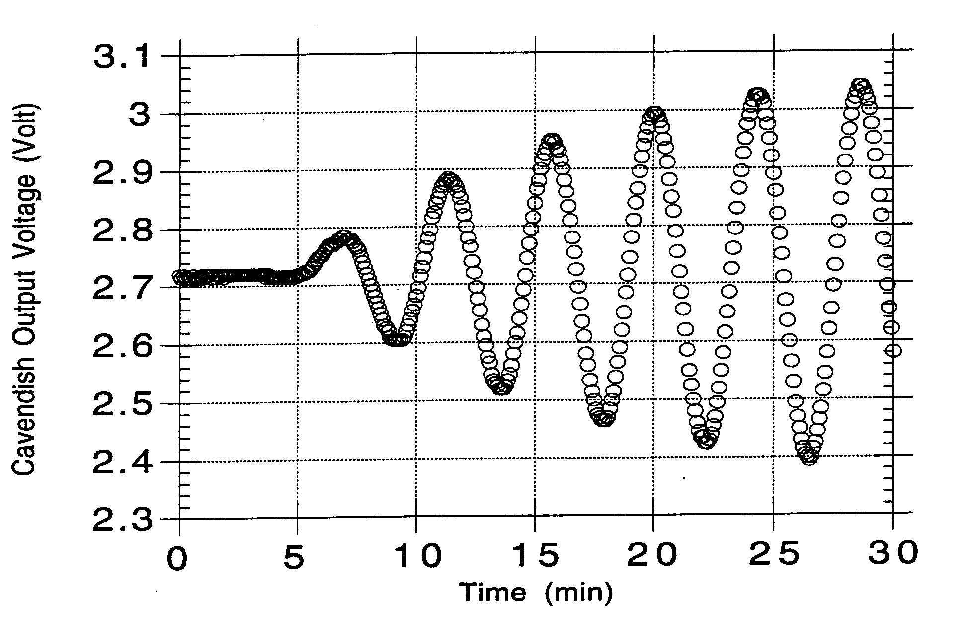
Figure B2. Cavendish balance output voltage versus time for the case of driven resonance oscillations. The first drive step occurs about 5 minutes after the recording process began.

Let ±θD be the change in the equilibrium angle when the large masses are rotated from the center position to either of the (symmetrically located) extreme positions. Suppose at time t=0 (a turning point if the balance is oscillating) the large masses are rotated to the extreme position where the new equilibrium angle is θe-θD. Then from Equation 2, the time dependence of the boom angle is

θ(t) = (θe-θD) + (θ1-(θe-θD)) e-bt [cos(ω1t )+b/ω1 sin(ω1t)] (10)

where θ1 is the angle of the boom at t=0 (the first turning point). The boom angle at the second turning point is

θ2 = (θe-θD) -x (θ1-(θe-θD)). (11)

At the second turning point (t=T/2) the large masses are quickly rotated so that the new balance equilibrium angle becomes θe+θD. Thus, the boom angle at the third turning point (t=T) is

θ3 = (θe+θD) -x (θ2-(θe+θD)). (12)

Each pair of adjacent turning points can be used to measure θD from which the gravitational constant G can be determined. It can be seen from Equations 11 and 12 that the solution for θD in terms of the two turning points θn and θn+1 is

θD = (-1)n[(θn+1 -θe)+x (θn -θe)]/(1+x). (13)

The equilibrium angle θe can be eliminated from the measurement process if the results of two measurements of θD using three adjacent turning points are averaged:

θD = (-1)n[x θn + (1-x) θn+1 -θn+2] / [2 (1+x)]. (14)

To reduce errors, the results of an odd number N of adjacent turning points can be averaged:

θD = [(1-x)(θ1-θ2+θ3-θ4+...θN) -θ1+ x θN] / [(N-1)(1+x)] (15)

where the error on θD is has contributions from the measurement error on the in
dividual turning points (δθDθ) and the error on x (δθDx):

δθD = [ δθDθ2 + δθDx2 ]1/2 (16a)

δθDθ = δθ [(N-1)(1-x)2 + 2x]1/2/[(N-1)(1+x)] (16b)

δθDx = δx [2(θ1-θ2+θ3-...-θN-1) + (θN-θ1)] / [(N-1)(1+x)2] (16c)

assuming the measurements errors on the individual turning points are uncorrelated and equal to δθ.
The minimum time required to collect the data needed to determine G is very short. Using Equation 7 to determine x and Equation 14 to determine θD, only 3 adjacent turning points when the balance is being resonantly driven and 3 adjacent turning points when the balance is in free decay need be measured. Each set of 3 measurements require the balance to oscillate through one complete cycle which, depending on the length of the tungsten fiber, is about 4 minutes or less. If more accuracy is desired, any odd number N of adjacent data points can be used to determine x and θD using Equations 8 and 14.

Once θD has been measured, the gravitational constant G can be determined. The torque exerted by the gravitational force of the large balls on the boom is balanced by a restoring torque of the tungsten fiber when it is rotated by the angle θD. The torque can be easily calculated if the following assumptions are made:

i) The balance is symmetric about the axis of rotation: the separation between the large and small masses is the same for both arms and for both equilibrium positions, the two large masses are identical, and the two small masses are identical.
ii) The mass of the aluminium beam is small and can be ignored.
iii) The positions of the large masses in both extreme positions is such that the gravitational force of the large masses on the small spheres is at right angles to the boom and in the plane perpendicular to the torsion fiber.
With these assumptions the gravitational torque τn of the large spheres on the nearby spheres is

τn = 2 G M m d /R2 (17)
where
M = mass of each large sphere,
m = mass of each small sphere,
d = distance from the rotation axis to the center of the small sphere,
R = distance between the centers of the large and small spheres.

Equating the gravitational torque to the restoring torque of the fiber (KθD) gives

G = K θD R2 / (2 M m d). (18)

The torsion constant K can be determined two different ways:
i) from the bulk properties of tungsten, K can be calculated from

K = (πμD4/32L) (19)

where D is the diameter of the fiber (25 μm), L is the length of the fiber, and μ = 1.57x1011 N/m2.
ii) from the equation for the oscillation frequency:

K = (4π2/T2 + b2) I. (20)

For this balance the b2 term is very small and can be ignored. The moment of inertia is the sum of the moment of inertia of the two small spheres (Is) plus the moment of inertia of the aluminium beam (Ib):

Is = 2(m d2 + 2/5 mr2) Ib = mb (lb2 + wb2)/12 (21)

where r = radius of the small sphere, and the aluminum beam is assumed to be a uniform rectangle rotated about its center with mass mb, length lb, and width wb.

Corrections:
The various assumptions that have been made in the above analysis introduce corrections to G for the non-ideal actual balance. The largest of these is the correction for the gravitational attraction of the large masses to the aluminum beam. A correction is also needed to account for the gravitational attraction of the large masses to the distant small masses. These and other corrections are discussed below.

1) Correction for the gravitational torque exerted on the beam.
The aluminium beam can be approximated by a rectangle containing two holes that are used to support the small spheres. The large spheres exert a torque on the beam but less effectively than on the small spheres since much of the beam is further away from the center of the large spheres, and the gravitational force is not at right angles to the lever arm about the rotation axis. To estimate this torque, we will approximate the beam by a thin rod of length lb having negligible thickness and width. If ∆m is the mass of a small piece of the rod located a distance x from the axis of rotation, the gravitational torque exerted by one large sphere on the small piece is given by

∆τb = G M ∆m d / R2 f (22)

where f is a factor which accounts for the reduction of the torque compared to the case where the mass ∆m was located at the center of the nearby small sphere:

f = x / d * [1 + ((d - x)/R)2]-3/2. (23)

For regions near the position of the small sphere (x = d) f is approximately 1, but it dies away rapidly as x moves away from the small sphere position so that for x = 1/2 d, f = 0.26, and for x = -1/2 d, f = -0.036. The average of f over the area of the holes for the small spheres is within 2% of 1. Thus, if we assume f=1 for the area of the holes, we will be making at most a 2% error on an already small correction. In that case, the affect of the holes can be accounted for by representing the beam by a uniform rod plus a point mass located at the center of the each hole whose mass mh is equal to the mass of the aluminium removed to make the hole, but negative. In other words, the value of the mass of the hole just subtracts from the mass of the small sphere that sits in the hole. The value of mh can be calculated from the density of aluminium (ρ = 2.70 g/cm3) and the dimensions of the hole (mh = ρ V = 0.34 g). Since the mass of the small spheres is about 14.6 g, this represents a 2% adjustment to the mass of the small sphere.
The torque exerted by a large sphere on the (now holeless) aluminium beam can be calculated by integrating ∆τb (Eq. 22) over the length of the beam lb:

1 sphere: τb = G M mb d / R2 fb (24)

where 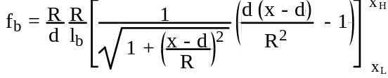 (25)

and where xL and xH are the positions of the two ends of the beam relative to the axis of rotation. Assuming the beam is symmetrically placed so that xL = -lb/2 and xH = +lb/2, Eq. 25 becomes

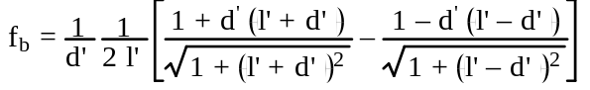 (26)

where d’ ≡ d/R and l’ ≡ lb/(2R). For the Cavendish balance, l’ = 1.57, d’ = 1.44, and fb = 0.19. Each large sphere exerts a torque on the beam, so the net torque exerted on the beam including the effects of the holes is

2 spheres: τb = 2 G M (mb fb - mh ) d / R2 . (27)

The ratio of the torques exerted by the large spheres on the beam over that exerted by the large spheres on the small masses is

τb / τn = (mb fb - mh ) / m (28)

which is about 7%.

2) Correction for the large sphere attraction to the distant small sphere.

The large spheres exert torques on the small spheres nearest them (Eq. 17), but they also exert oppositely directed torques on the distant small spheres. Compared to the torque exerted on the nearby sphere, this torque is reduced in magnitude both because the distant small spheres are much further away, and the gravitational force is no longer perpindicular to the lever arm. Including both effects, the torques exerted by the large spheres on the distant small spheres is given by

2 spheres: τd = - 2 G M m d /R2 fd (29)

where fd = f = R3 / [R2 + (2d)2]3/2. (30)

For the Cavendish balance, fd = 3.5%.

3) Determining R:
To determine the separation R between the centers of the large and small spheres, it is easiest to assume the boom has been oriented so that at equilibrium, it is parallel to the glass plates and located midway between them. Ignoring the small rotation of the boom caused by the gravitational torques exerted by the large spheres, when the large spheres are just touching the glass windows R is given by

R = W/2 + RL (31)

where W is the separation of the two outer surfaces of the glass planes, and RL is the radius of the large spheres. In practice, the diameters of the two large spheres, DL1 and DL2, are most easily measured. Furthermore, due to machining tolerances in the balance frame and imperfections in the surfaces of the large spheres, a small gap may exist between the surface of the glass window and one large sphere when the other large sphere is making contact with the glass surface. To account for these small gaps (typically less than 1 mm), it is convenient to average them and add the average to the separation W between the two glass surfaces. If G1 and G2 are the sizes of the gaps when the large spheres are in the two extreme
positions, then R can be calculated from

R = W/2 + (DL1 + DL2)/4 + (G1+G2)/2. (32)

Corrections for the assumption that at equilibrium the boom is oriented parallel to the glass surfaces and midway between them turn out to be small. Suppose that the actual position of a small sphere at the equilibrium position is displaced from the assumed central position by an amount δ in a direction perpindicular to the boom. In this case, when the large spheres are in one position the true R will be smaller than the assumed R by the amount δ, but in the other extreme position the true R will be larger than the assumed R by δ. Thus, the strength of the gravitational force between the large and small spheres will be different for the two orientations of the large spheres. If the method used to obtain G treats the two extreme positions symmetrically, then the average of the two gravitational forces is the important quantity, and this average is only weakly sensitive to δ:

[ 1/(R+δ)2 + 1/(R-δ)2] /2 ≈ 1/R2 [ 1 + 3 (δ/R)2 ]. (33)

For example, if δ happens to be 3 mm, the correction to the average gravitational force from Eq. 33 for the Cavendish balance (R ≈ 4.6 cm) is only 1.3%. When aligning the balance, the equilibrium position of the boom should be adjusted to within this accuracy. Note that the above argument assumes the two extreme positions of the large spheres are treated symmetrically. For the driven oscillation method, this condition will be better satisfied as more oscillations are averaged.

Corrections for the assumption that R (Eq. 32) doesn’t change during the measurement depends on the method used to determine G. For the driven oscillation method averaged over many cycles, for each position of the large spheres the boom moves in an approximately symmetric manner with respect to the equilibrium position spending about equal amounts of time with R both larger and smaller than the equilibrium value. Using an argument similar to the one given above, the correction to G due to the assumption that R doesn’t change is small. This is not true for the static method where G is determined from the change in the boom angle when the spheres are moved from one extreme position to the other. For this method, a correction to G from this effect of about 2% is required.

Combining the results discussed above yields the following equation for the total torque exerted by the large spheres on the boom:

τ = τn +τd + τb = 2 G M [(m -mh)(1-fd) + mbfb] d /R2. (34)

Equating the total gravitational torque to the restoring torque of the fiber (KθD) gives

G = K θD R2 / (2 M [(m -mh)(1-fd) + mbfb] d. (35)

